6th Grade/Module 5-Lesson 8/Mrs. Faour

Drawing Polygons in the Coordinate Plane

Classwork

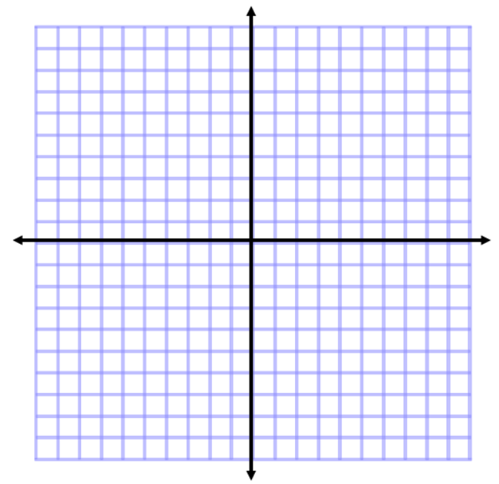**Examples**

$$y$$

$$x$$

1. Plot and connect the points $A(3, 2)$, $B(3, 7)$, and $C(8, 2)$. Name the shape, and determine the area of the polygon.
2. Plot and connect the points $E(-8, 8)$, $F(-2, 5)$, and $G(-7, 2)$. Then give the best name for the polygon, and determine the area.
3. Plot and connect the following points: $K(-9, -7)$, $L(-4, -2)$, $M(-1, -5)$, and $N(-5, -5)$. Give the best name for the polygon, and determine the area.
4. Plot and connect the following points: $P(1, -4)$, $Q(5, -2)$, $R(9, -4)$, $S(7, -8)$, and $T(3, -8)$. Give the best name for the polygon, and determine the area.

Problem Set

Plot the points for each shape, determine the area of the polygon, and then write an expression that could be used to determine the area of the figure.

$$y$$

$$x$$

1. $A(1, 3)$, $B(2, 8)$, $C(8, 8)$, $D(10, 3)$, and $E(5, -2)$



1. $X(-10, 2)$, $Y(-3, 6)$, and $Z(-6, -5)$



$$y$$

$$x$$

1. $E(5, 7)$, $F(9, -5)$, and $G(1, -3)$



$$y$$

$$x$$

1. Find the area of the triangle in Problem 3 using a different method.
2. Two vertices of a rectangle are $(8, -5)$ and $(8, 7)$. If the area of the rectangle is $72$ square units, name the possible location of the other two vertices.
3. A triangle with two vertices located at $(5, -8)$ and $(5, 4)$ has an area of $48$ square units. Determine one possible location of the other vertex.